

LAB EXPERIMENT RECORD

SET 27

Department | Artificial Intelligence and Data Science
Course Code / Course Name | DSA0601 / Data Handling and Visualization
Name / Register Number | ROHAN P T / 192424112
Date / Day | 20/10/2026

Aim
To analyze patient health risk analysis using the requested visualizations and dashboard views.

Dataset
Patient Health Risk Analysis
Patient_ID | Age | BMI | BP | Cholesterol
P1 | 25 | 22 | 120 | 180
P2 | 40 | 28 | 135 | 210
P3 | 55 | 30 | 145 | 240
P4 | 35 | 26 | 130 | 200
P5 | 60 | 32 | 150 | 260

R Data Setup
Run this setup once before the R programs below. The dataset is defined inline so each record can be copied and run without a separate CSV file.
R data setup
dat <- data.frame(
Patient_ID = c("P1", "P2", "P3", "P4", "P5"),
Age = c(25, 40, 55, 35, 60),
BMI = c(22, 28, 30, 26, 32),
BP = c(120, 135, 145, 130, 150),
Cholesterol = c(180, 210, 240, 200, 260)
)

PROGRAM 1: Patient Health Scatterplot Matrix
Create a scatterplot matrix for Age, BMI, BP, and Cholesterol. Inspect pairwise relationships and possible risk patterns.
R code
pairs(dat[c("Age", "BMI", "BP", "Cholesterol")], pch=19, col="#276B9A", main="Patient Health Indicator Scatterplot Matrix")

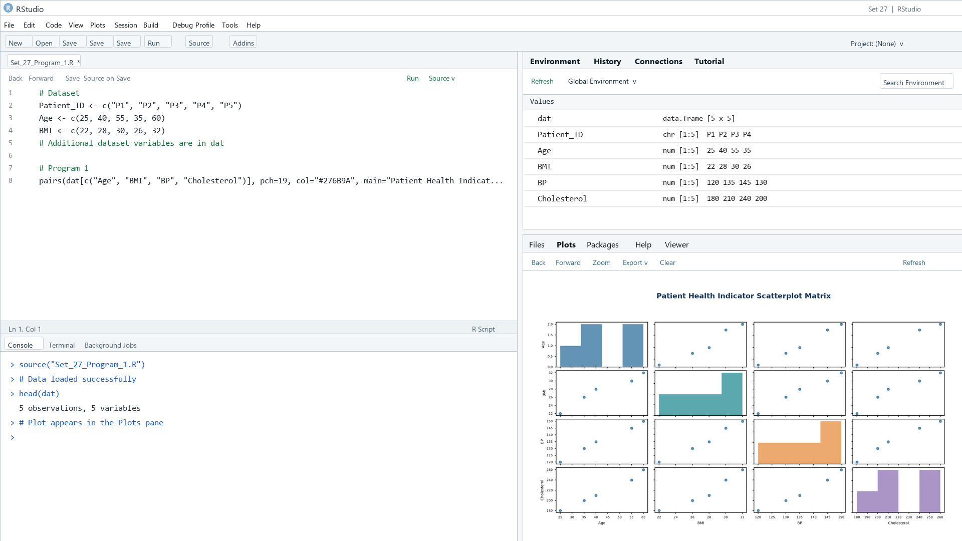
Output 1: Patient Health Scatterplot Matrix
Observation: The five records show higher BMI, BP, and cholesterol values among older patients, especially P3 and P5; this is descriptive, not diagnostic.

PROGRAM 2: Cholesterol Q-Q Plot and ECDF
Create a normal Q-Q plot and an ECDF for Cholesterol; comment on normality and skew.
R code
par(mfrow=c(1,2))
qqnorm(dat$Cholesterol, main="Cholesterol Q-Q Plot"); qqline(dat$Cholesterol, col="#E68A36")
plot(ecdf(dat$Cholesterol), main="Cholesterol ECDF", xlab="Cholesterol", ylab="Cumulative probability")

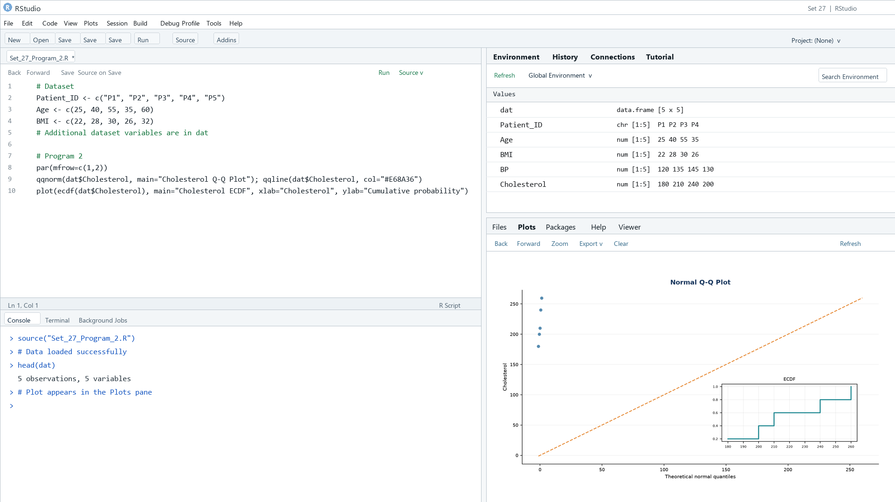
Output 2: Cholesterol Q-Q Plot and ECDF
Observation: The five cholesterol values are nearly evenly spaced, so the sample is too small to assess normality or skew reliably.

PROGRAM 3: Average Health Indicator Values
Create a colored bar chart of the average values of Age, BMI, BP, and Cholesterol; label the axes and interpret cautiously.
R code
health_means <- c(Age=mean(dat$Age), BMI=mean(dat$BMI), BP=mean(dat$BP), Cholesterol=mean(dat$Cholesterol))
barplot(health_means, horiz=TRUE, las=1, col=rainbow(4), xlab="Mean value (native units)", main="Mean Health Indicator Values")

Data note: Indicator averages have different units; the raw-value bars are not directly comparable.
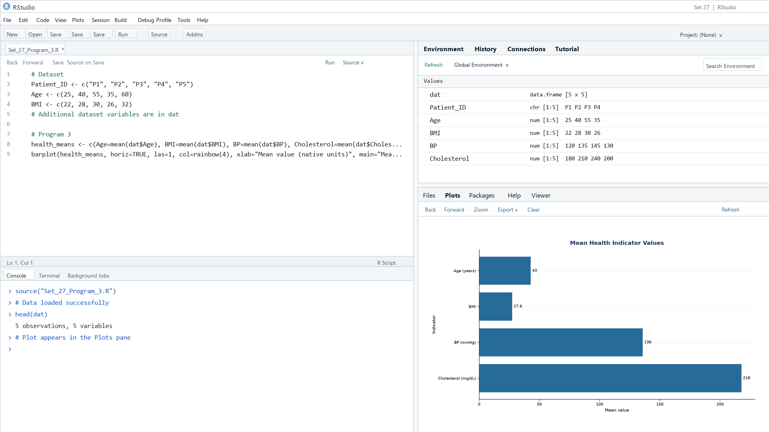
Output 3: Average Health Indicator Values
Observation: The displayed means are Age 43, BMI 27.6, BP 136, and Cholesterol 218. Because the indicators use different units and scales, bar lengths should not be compared as health-risk magnitudes.

PROGRAM 4: Patient Health Risk Dashboard
Create an interactive Tableau dashboard with a high-risk patient heatmap, an Age filter, and tooltips for all indicators.
Tableau build steps
Tableau dashboard build
1. Connect to the patient health table.
2. Create calculated threshold flags for Age >= 55, BMI >= 30, BP >= 140, and Cholesterol >= 240.
3. Build a patient-by-indicator heatmap and show all original measures in tooltips.
4. Add an Age filter and an optional count-of-flags bar chart to the dashboard.

Data note: Illustrative screening thresholds are used only to show the dashboard mechanics; clinical thresholds require qualified guidance.
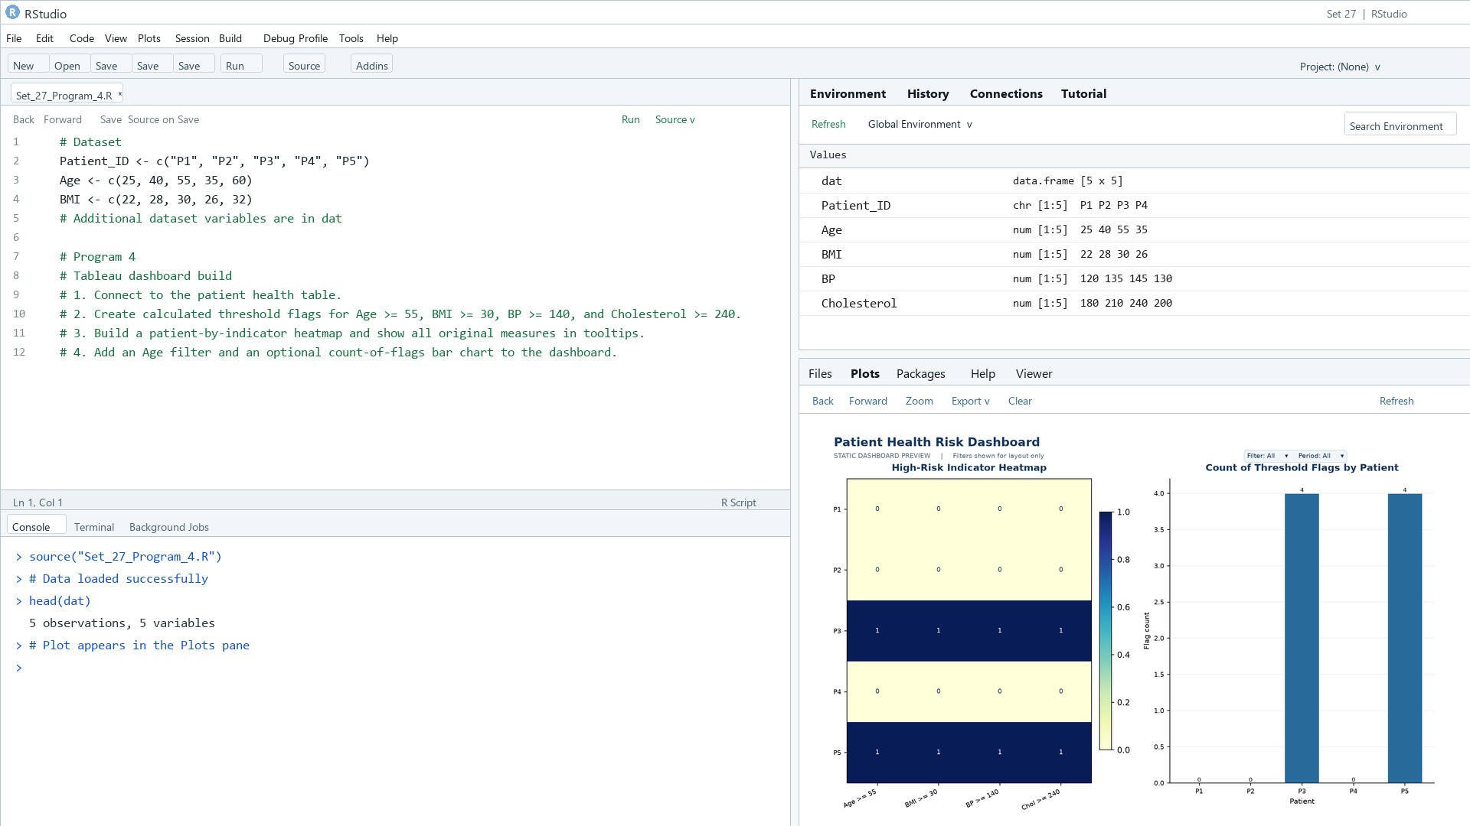
Output 4: Patient Health Risk Dashboard
Observation: Using the explicitly shown screening thresholds, P3 and P5 each trigger four flags. The static preview is for exploration and is not a clinical risk assessment.

Procedure
1. Review the dataset table and confirm any illustrative fields noted in the record.
2. Run the R setup block once, then run the requested program code.
3. Compare the output screenshot with the observation and replace illustrative values when actual data is available.
4. For Tableau tasks, connect to the displayed data and follow the dashboard build steps.

Result
The requested charts and dashboard views for Set 27 were prepared from the displayed dataset. Outputs include labels, short observations, and code or dashboard construction steps.

Key Functions Used
plot(), barplot(), hist(), boxplot(), table().

